**PROGRAMMING IN PYTHON**

**Lab Exercise - 8**

**“Dictionary DS & FUNCTIONS”**

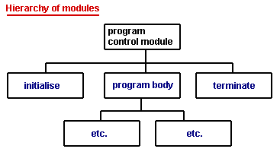

**Name – Purushottam Kumar**

**ID – 2041**

**Date - 27th Feb 2021**

* **DICTIONARY BASED PROBLEMS**

1. Write a program that uses a dictionary to store states and their codes. Print the dictionary.

( First create an empty dictionary and add keys and values by getting user input )

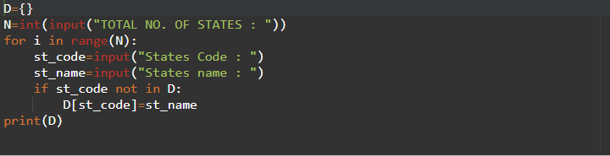

**OUTPUT :**

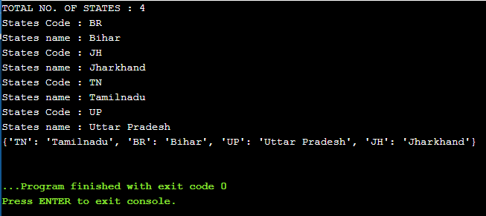

1. WAP to search for the presence or absence of a state code from the dictionary created in program 1.

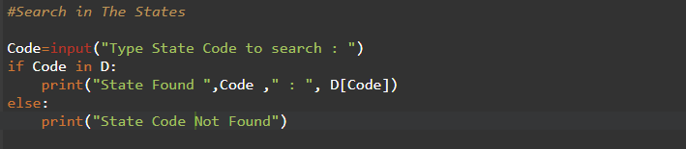

**OUTPUT :**

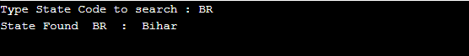

1. Write a program to create a dictionary using dictionary comprehension. The keys must be odd numbers in the range 1-100 and the values must be the cube of the key

Num={x:x*x*x for x in range(1,101) if x%2==1}

for i in sorted(Num.keys()):

print(i,Num[i])

**OUTPUT :**

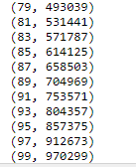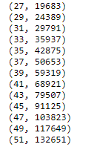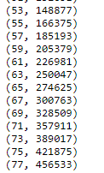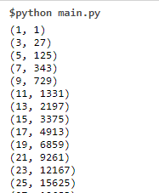

1. Write a program that calculates fib(n) using dictionary.

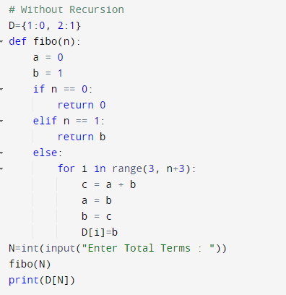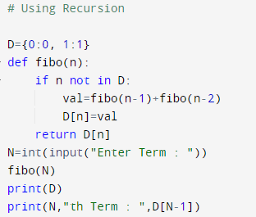

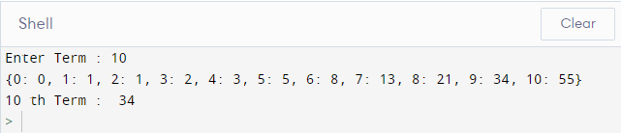**OUTPUT :**

1. Write a program to store a matrix using dictionary. The key is (row, column) information and values is the number in that matrix location.

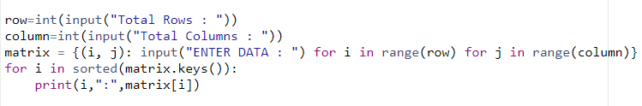

**OUTPUT :**

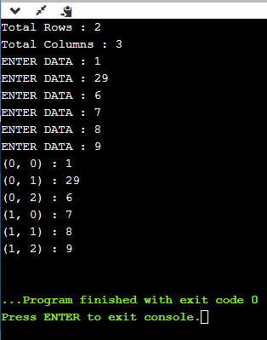

**PART-2 “FUNCTIONS BASED PROBLEM”**

1. Write a program using functions to check whether two numbers are equal or not.

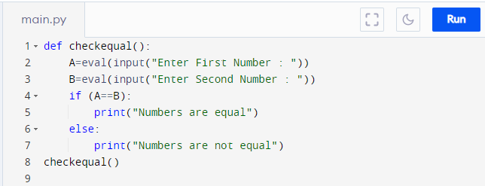

**OUTPUT :**

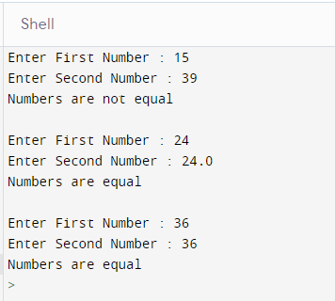

1. Write a program to swap two numbers.

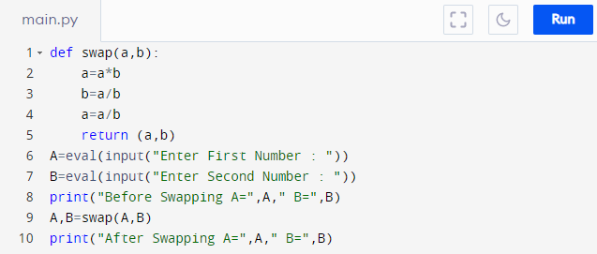

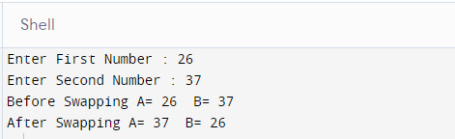

**OUTPUT :**

1. Write a program to return the complete address of a person. ( Accept separate information about door no, building name, street name, locality name, city name, state name, pin code )

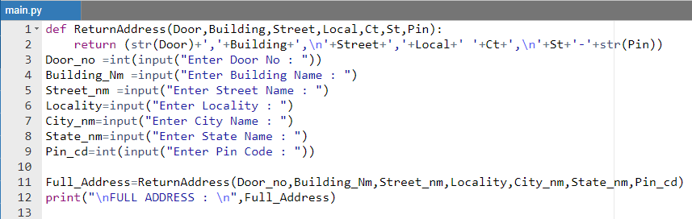

**OUTPUT :**

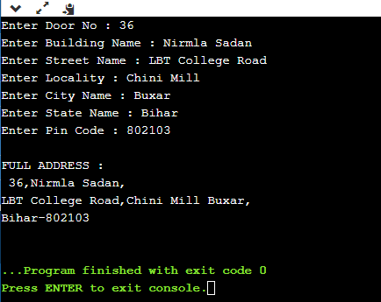

1. Write a program to return the average of its arguments.

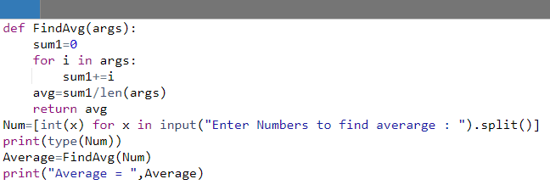

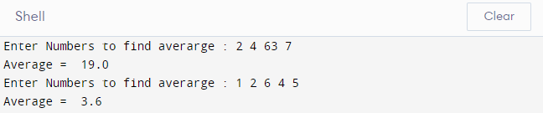

1. Write a program using function and return statement to check whether a number is Armstrong number or not.

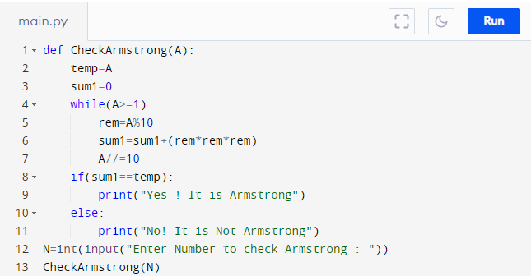

**OUTPUT**

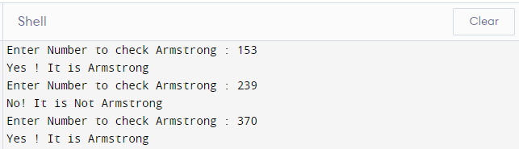

1. Write a program to reverse a string using recursion.

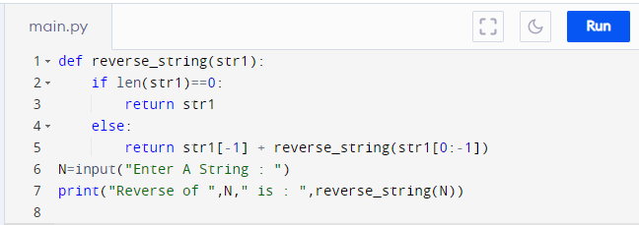

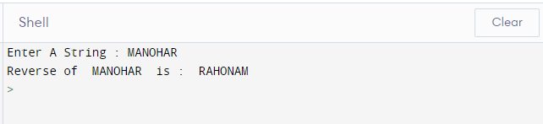

**OUTPUT**

1. Write a program to find the largest of three numbers.

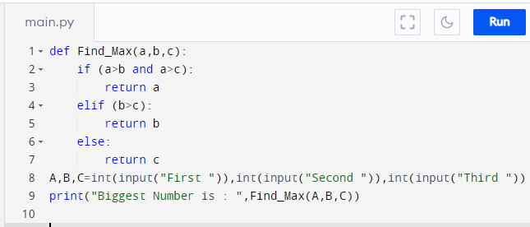

OUTPUT



